**Game Design Document**

**Title: Forest Road Rush**

**Version: 1.0**

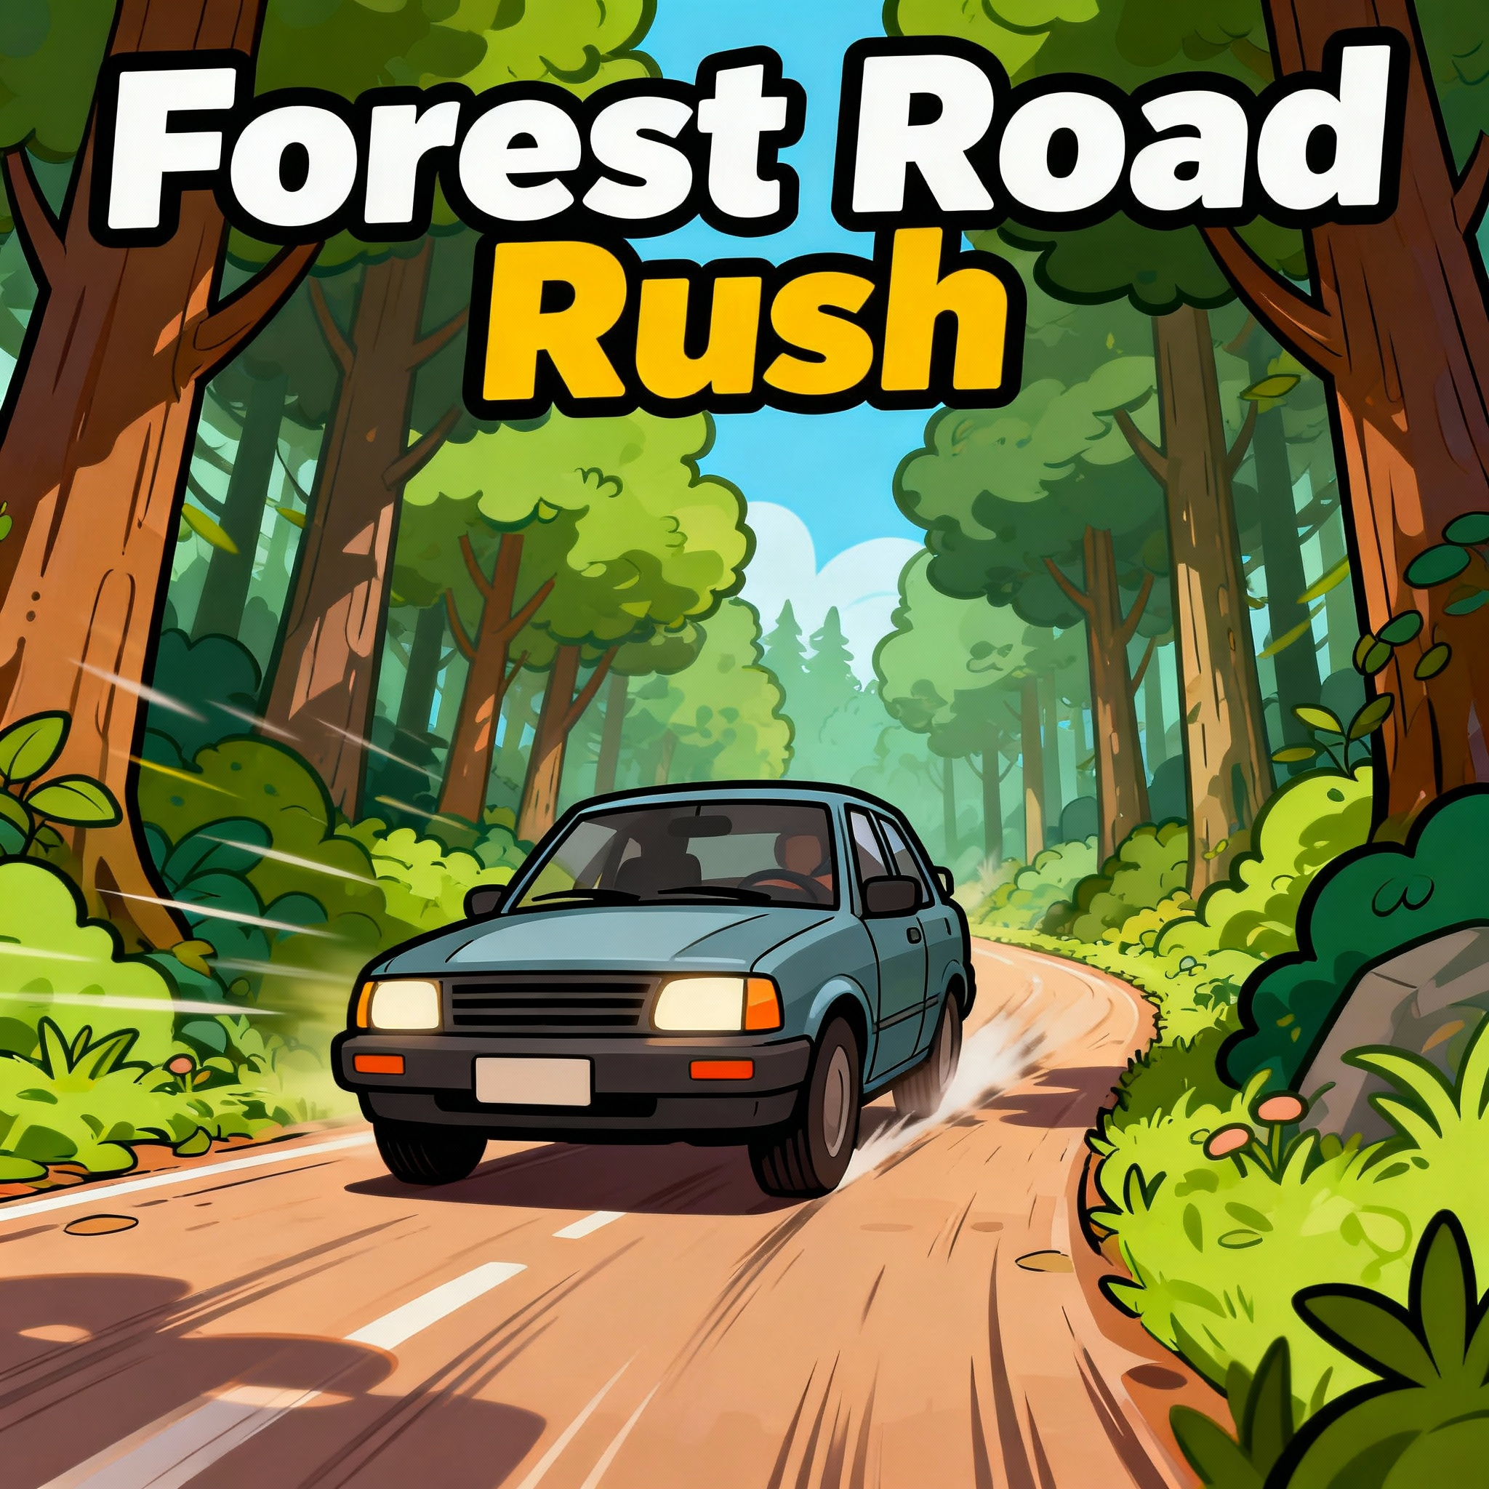

Author: ARAVINDRAJ.K

Table of content

|  |  |  |
| --- | --- | --- |
| Sno | Topic | Page no |
| 1 | Game overview  1.1 High concept  1.2 core gameplay pillars  1.3 vision statement | 3-4 |
| 2 | Version History | 4 |
| 3 | Gameplay Mechanics  3.1 Player Controls  3.2 Objectives  3.3 Obstacles  3.4 Collectibles  3.5 Difficulty Scaling  3.6 Game Over Conditions  3.7 Scoring System | 5-7 |
| 4 | Game World  4.1 Setting  4.2 Environment Assets | 7-8 |
| 5 | User Interface (Ui)  5.1 HUD (In-Game)  5.2 Game Over Screen  5.3 Main Menu | 8 |
| 6 | Audio Design | 9 |
| 7 | Visual Style & Art Direction | 9 |
| 8 | System Design  8.1 Technical Specs  8.2 Object Management  8.3 Save System | 10 |
| 9 | Difficulty Progression | 11 |
| 10 | Future Version Plan (V2.0 & Beyond) | 11 |
| 11 | Development Milestones | 12 |
| 12 | Asset List | 13 |
| 13 | Appendix  13.1 Tags Setup (in Unity)  13.2 Required Components | 13 |
| 14 | Release Details | 14 |
| 15 | Project submission details | 15 |

**GAME OVERVIEW**

**Project Title**: Forest Road Rush – Version 1.0

### **Genre:** Endless Driving / Survival

### **Engine**: Unity 6

### **Platform:** PC,

### **Team:** Solo / Indie

### **Current Stage:** Prototype to Version 1.0 (Core Mechanics)

### Next Version (v2.0) Preview: Dynamic weather, skidding mechanics, opposite-traffic cars as obstacles.

### **1.1 High Concept**

Forest Road Rush is a fast-paced **endless driving game** where players control a car speeding down a forest road. The goal is simple: **collect as many coins as possible** while avoiding obstacles and hazards. Over time, the game increases in difficulty by speeding up, reducing spawn intervals, and adding environmental hazards.

### **1.2 Core Gameplay Pillars**

* Simple Controls: Left / Right movement on a continuous forward-driving car.
* Immersive Environment: Forest-themed track with trees, coins, and falling obstacles.
* Replayability: Increasing difficulty curve, coin collection, and a persistent high-score system.
* Atmosphere: Smooth skybox lighting with ambient forest sounds.

**1.3 Vision Statement**

A casual yet thrilling endless driving game set on a scenic forest road — visually immersive, easy to play, and rewarding to master.

**2. VERSION HISTORY**

|  |  |  |
| --- | --- | --- |
| Version | Features | Status |
| v1.0 | Core gameplay: driving, coins, obstacles, trees, difficulty scaling, high score UI | Current |
| v2.0 (Planned) | Weather system (rain, fog, day/night), car skidding physics, oncoming traffic cars as moving obstacles | In Design |

**3. GAMEPLAY MECHANICS**

**3.1 Player Controls**

|  |  |
| --- | --- |
| Inputs | Actions |
| A / Left Arrow | Move car left |
| D / Right Arrow | Move car right |

1. The car moves forward automatically.
2. Movement is clamped within the road boundaries.

**3.2 Objectives**

1. **Primary Goal**: Survive as long as possible while collecting coins.
2. **Secondary Goal:** Beat your previous high score.

**3.3 Obstacles**

* Static Obstacles: Fallen logs, rocks, cones, barrels, etc.
* Dynamic Obstacles: Falling trees or debris.
* *(v2.0)* Oncoming Cars: Spawned in the opposite lane, move toward the player.

**3.4 Collectibles**

**Coins:**

* Increase score by +1 per coin.
* Play pickup sound.
* Update coin count and high score if applicable**.**

**3.5 Difficulty Scaling**

* Every *X* seconds, the forward speed increases slightly.
* Spawn intervals for obstacles decrease.
* This continues indefinitely until Game Over.

**3.6 Game Over Conditions**

* Collision with an obstacle or snake (hazard).
* (Future) Collision with an oncoming vehicle.

**When Game Over occurs:**

* The car stops moving.
* GameOver UI shows Final Score, Time, and High Score.
* Buttons appear for PlayAgain! Or Main Menu.

**3.7 Scoring System**

|  |  |
| --- | --- |
| Event | Coins |
| Collect Coin | **+**2 |
| Survive 10s | nil |
| Beat Previous High Score | Saves new record via PlayerPrefs |

**4. GAME WORLD**

**4.1 Setting**

* Theme: Dense forest with road stretching infinitely forward.
* Environment: Trees line both sides, slight variations in scale and rotation for realism.
* Skybox: Clear blue sky (URP skybox material).
* *(Future)* Dynamic clouds, fog, rain.

**4.2 Environment Assets**

|  |  |
| --- | --- |
| Element | Description |
| Road | Long repeating mesh or tiled prefab |
| Trees | Static prefabs randomly placed along the sides |
| Coins | Floating collectibles (trigger colliders) |
| Obstacles | Prefabs dropped/spawned periodically |
| Background | Skybox (material) |

**5. USER INTERFACE (UI)**

**5.1 HUD (In-Game)**

* Coins: “Coins: X”
* Time Survived: “Time: s”
* High Score: “High Score: Y”

### 

### **5.2 Game Over Screen**

* Final Score
* Final Time
* High Score
* Buttons: Restart, Main Menu

**5.3 Main Menu**

* Title “Forest Road Rush”
* Buttons: Play, Quit

**6. AUDIO DESIGN**

|  |  |
| --- | --- |
| Event | Sound |
| Coin Pickup | coin_pickup.wav |
| Background Music | forest_drive_theme.mp3 |

(Future versions will include ambient rain, thunder, and skidding tire SFX.)

**7. VISUAL STYLE & ART DIRECTION**

* **Art Style**: Semi-realistic or low-poly forest aesthetics.
* **Lighting:** Directional sunlight, soft shadows, natural tones.
* **Camera:** Third-person follow behind car (slightly elevated angle).

**8. SYSTEM DESIGN**

**8.1 Technical Specs**

|  |  |
| --- | --- |
| System | Description |
| Engine | Unity 6 |
| Physics | Rigidbody (with freeze rotation) |
| Input | Legacy Input or Unity Input System |
| Build Target | PC |
| FPS Target | 60 FPS |

**8.2 Object Management**

**Spawners:**

* ObstacleSpawner for hazards.
* CoinSpawner for collectible coins.
* TreeSpawner for environment decoration.
* Pooling (future optimization): Reuse prefabs instead of destroying.

**8.3 Save System**

* Uses PlayerPrefs to store:
* Retrieves and displays high scores every game start

**9. DIFFICULTY PROGRESSION**

|  |  |  |  |
| --- | --- | --- | --- |
| Time (s) | Forward Speed | Spawn Interval | Comment |
| 0 | 15 | 2.5s | Base Speed |
| 30 | 18 | 2.0s | Medium challenge |
| 60 | 22 | 1.5s | Fast pace |
| 90 | 25 | 1.0s | Hard mode |
| 120+ | 28+ | 0.7s | Extreme |

(All adjustable in Inspector for fine-tuning.)

**10. FUTURE VERSION PLAN (v2.0 & Beyond)**

v2.0 – "Weather & Traffic Update"

|  |  |
| --- | --- |
| Feature | Description |
| Dynamic Weather | Random weather changes — rain, fog, day/night cycle |
| Skidding Mechanic | Reduced traction on wet roads (inertia effect) |
| Opposite Cars | AI cars driving toward the player, serve as moving obstacles |
| Road Conditions | Wet surface visuals + rain particle effects |
| Performance Optimization | Object pooling for cars and trees |

**11. DEVELOPMENT MILESTONES**

|  |  |  |
| --- | --- | --- |
| Milestone | Task | Deliverable |
| 1 | Setup project + road + camera follow | Functional prototype |
| 2 | Add car movement and controls | Smooth drive feel |
| 3 | Add coin and obstacle spawning | Core gameplay |
| 4 | UI & GameOver screen | Playable loop |
| 5 | Add sound & high score saving | Polished gameplay |
| 6 | Add environment (trees, skybox) | Visual completeness |
| 7 | QA testing & balancing | v1.0 release |

**12. ASSET LIST**

|  |  |  |
| --- | --- | --- |
| Category | Asset | Source |
| Car Model | Sports car prefab | Unity Asset Store / TurboSquid |
| Trees | ForestPack | Unity Asset Store |
| Obstacles | Box | Custom |
| Coins | Coin prefab | Custom |
| Music | Theme,coin | Freesounds.com |

**13 .APPENDIX**

**13.1 Tags Setup (in Unity)**

|  |  |
| --- | --- |
| Object | Tag |
| Coin | Coin |
| Obstacle | Obstacle |
| Snake | Snake |
| Player | Player |

**13.2 Required Components**

* Player: Rigidbody (use gravity), Collider (box), PlayerController.cs
* Coins: Collider (IsTrigger = true)
* Obstacles: Collider + Rigidbody
* Spawners: Scripts for each spawn type
* UI: Canvas + TMP elements

**14. RELEASE DETAILS**

|  |  |  |  |
| --- | --- | --- | --- |
| Build Type | Platform | Version | Distribution |
| Prototype | PC | v1.0 | Local |

Project Submission

On

**Forest Road Rush**

(Capstone Project - WEARE1 Game Development cohort 2025)

Submitted by

**ARAVINDRAJ KASILINGAM**

WEARE1 Game Development course

Guided By

Mr. Nikhil Malankar Founder & CEO, GameEon Studios Instructor – WEARE1 Game Development Course

Submitted To

WEARE1 (We Are Gamers) In Collaboration with GameEon Studios Mumbai, Maharashtra, India

 

**Academic Year: 2025**